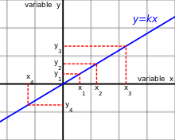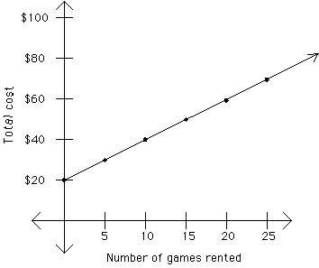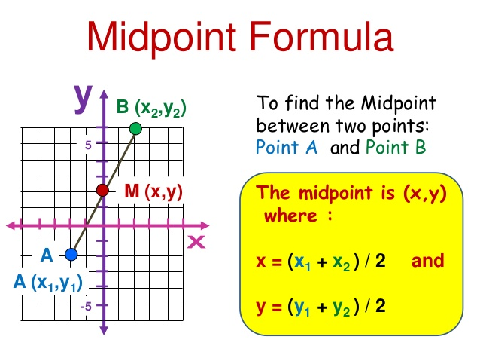*1.1.1 Mid-point*

*Direct Proportion*

Eg.

|  |  |  |  |  |  |  |
| --- | --- | --- | --- | --- | --- | --- |
| x | 1 | 2 | 3 | 4 | 5 | 6 |
| y | k | 2k | 3k | 4k | 5k | 6k |

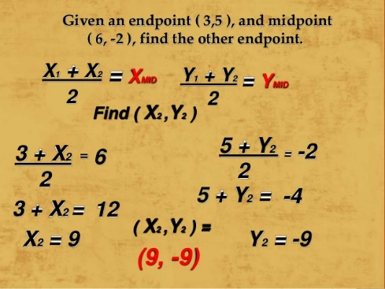

k

k

k

k

k

k

y= x

Difference:

Is a straight line gradient that passes through (0,0)

As the x-value is increased by 1 the y-values show a constant difference of k

* Both the x and y value increase or decreases in a constant amount
* Therefore, creating a straight line

*1.2.3* *Linearly Related Variables*

Eg.

1. Subt. The midpoint into the midpoint formula
2. Separate the X and Y values
3. Subt. The end point
4. Work out

1.1.2  *Finding end point*

Linear Equation: y=mx + c

When c is the y-intercept

**if line cuts y- axis

y = mx + c

1.1.4 *Linear Equations*

To Find the Distance of Two Points:

To find the gradient:

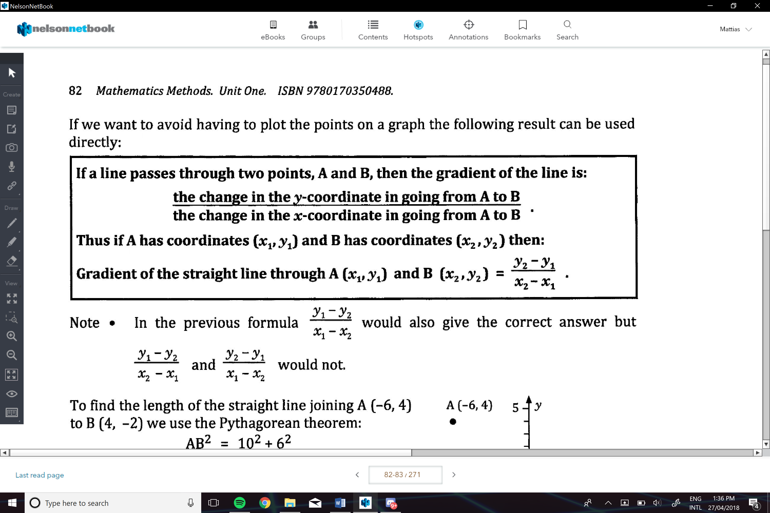

Where the line goes through the y axis

If increased by 5 units then it will transform the line 5 units vertically upwards

Y-intercept (c)

1

2

e.g. m=1/2

1

5

e.g. m=5

The more m increases the steeper the line is

If 0>m then the line is decreasing

If m>0 then the line is increasing

* Can determine if the line is increasing or decreasing
* Can determine the steepness

Gradient (m)

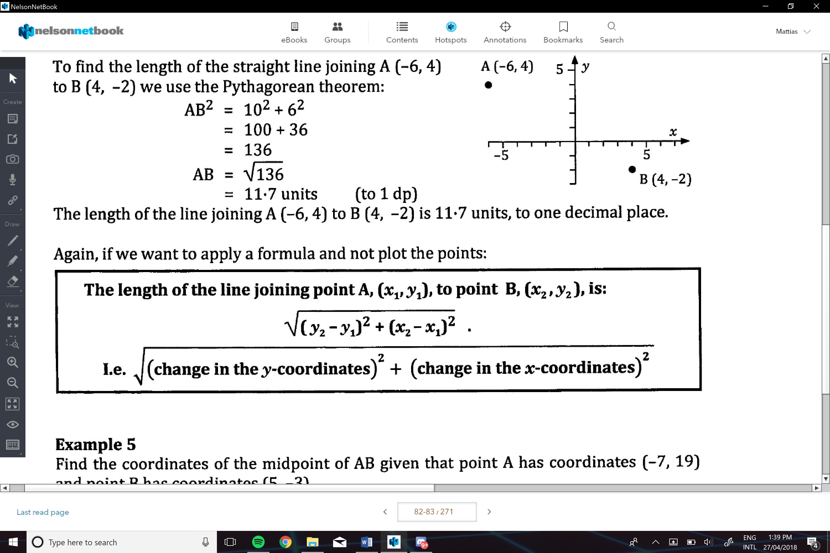

e.g.

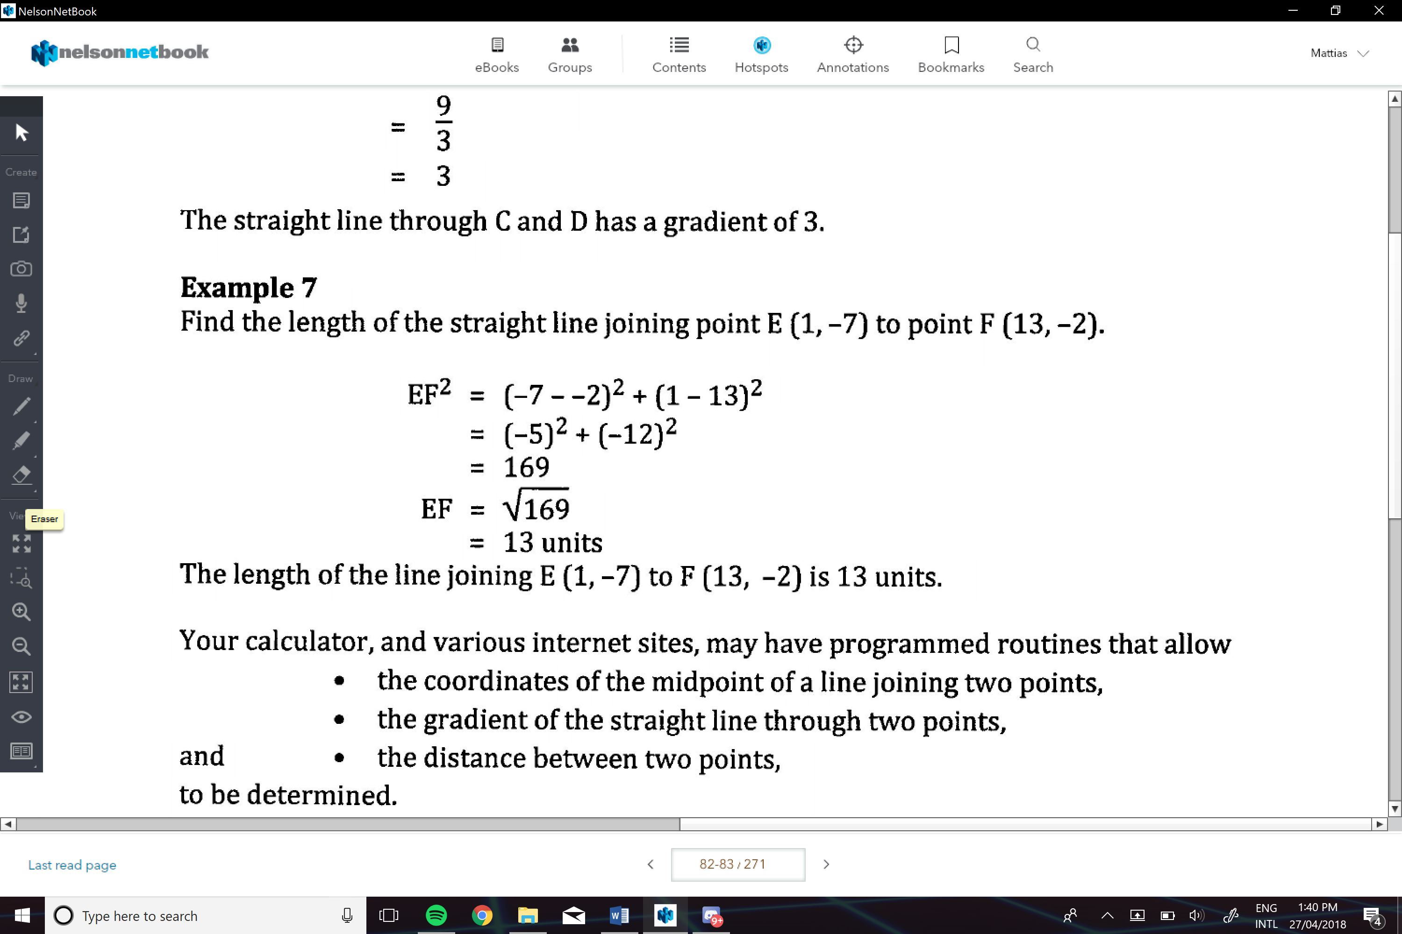

**Determining the Equation of a Staight Line:**

If given the gradient and on other point:

1. Subt. the gradient into y=mx+c
2. Subt. the given point
3. Find c
4. Then enter the gradient and y-intercept to find the equation

e.g.

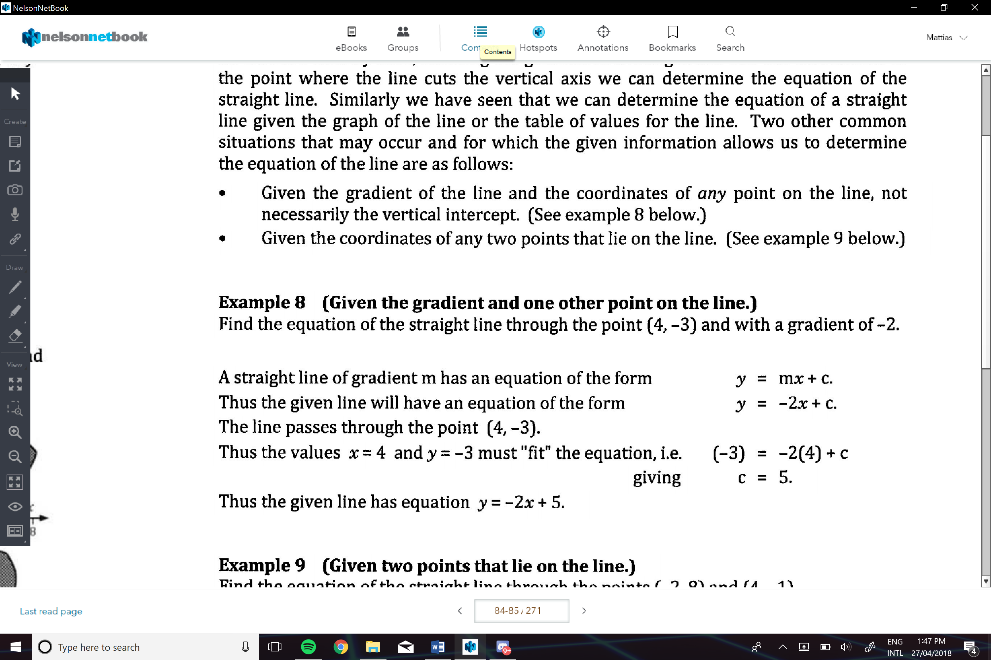

Given Two Points on the Line:

1. Find the gradient of the line
2. Subt. M into y=mx+c
3. Subt. one of the point
4. Finc c
5. Then enter the gradient and y-intercept to find the equation

e.g.

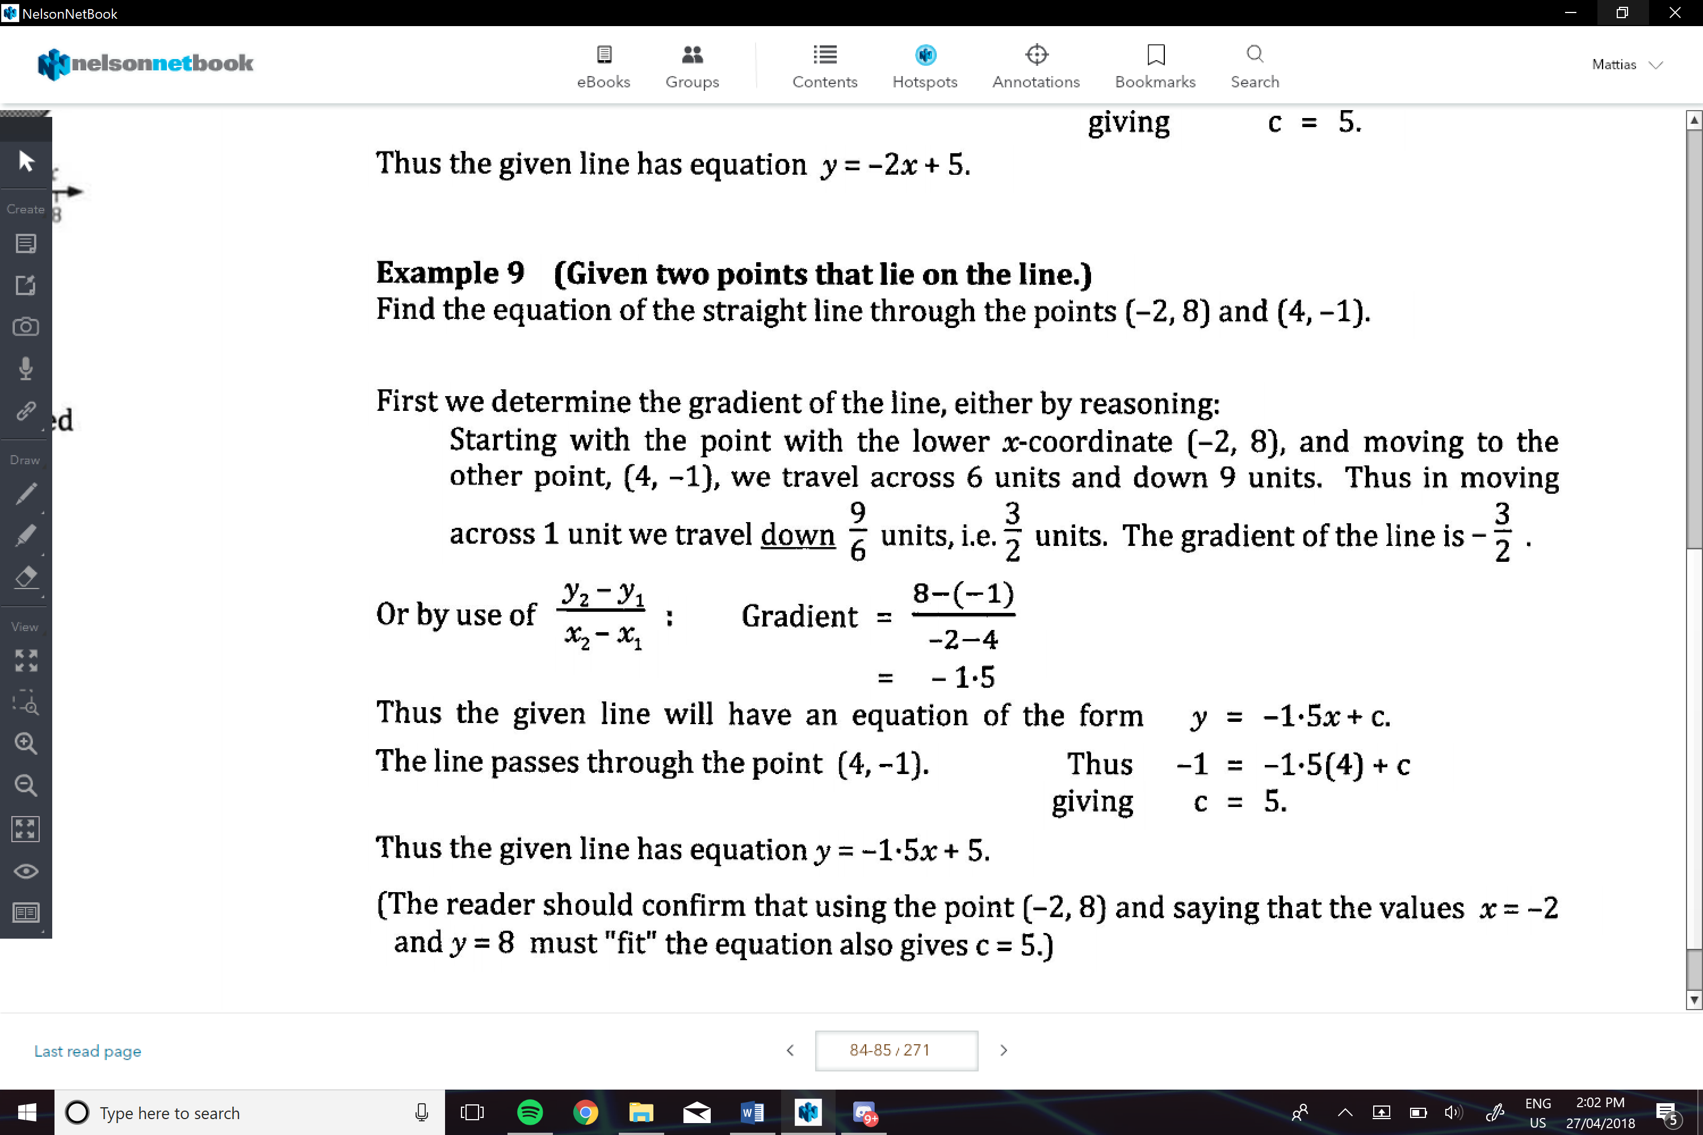

Given enough info that allows us to determine two points that lie on the line

* Then proceed like previous ways.

1. Find one point
2. Find the second point
3. Find the gradient
4. Find c

e.g.

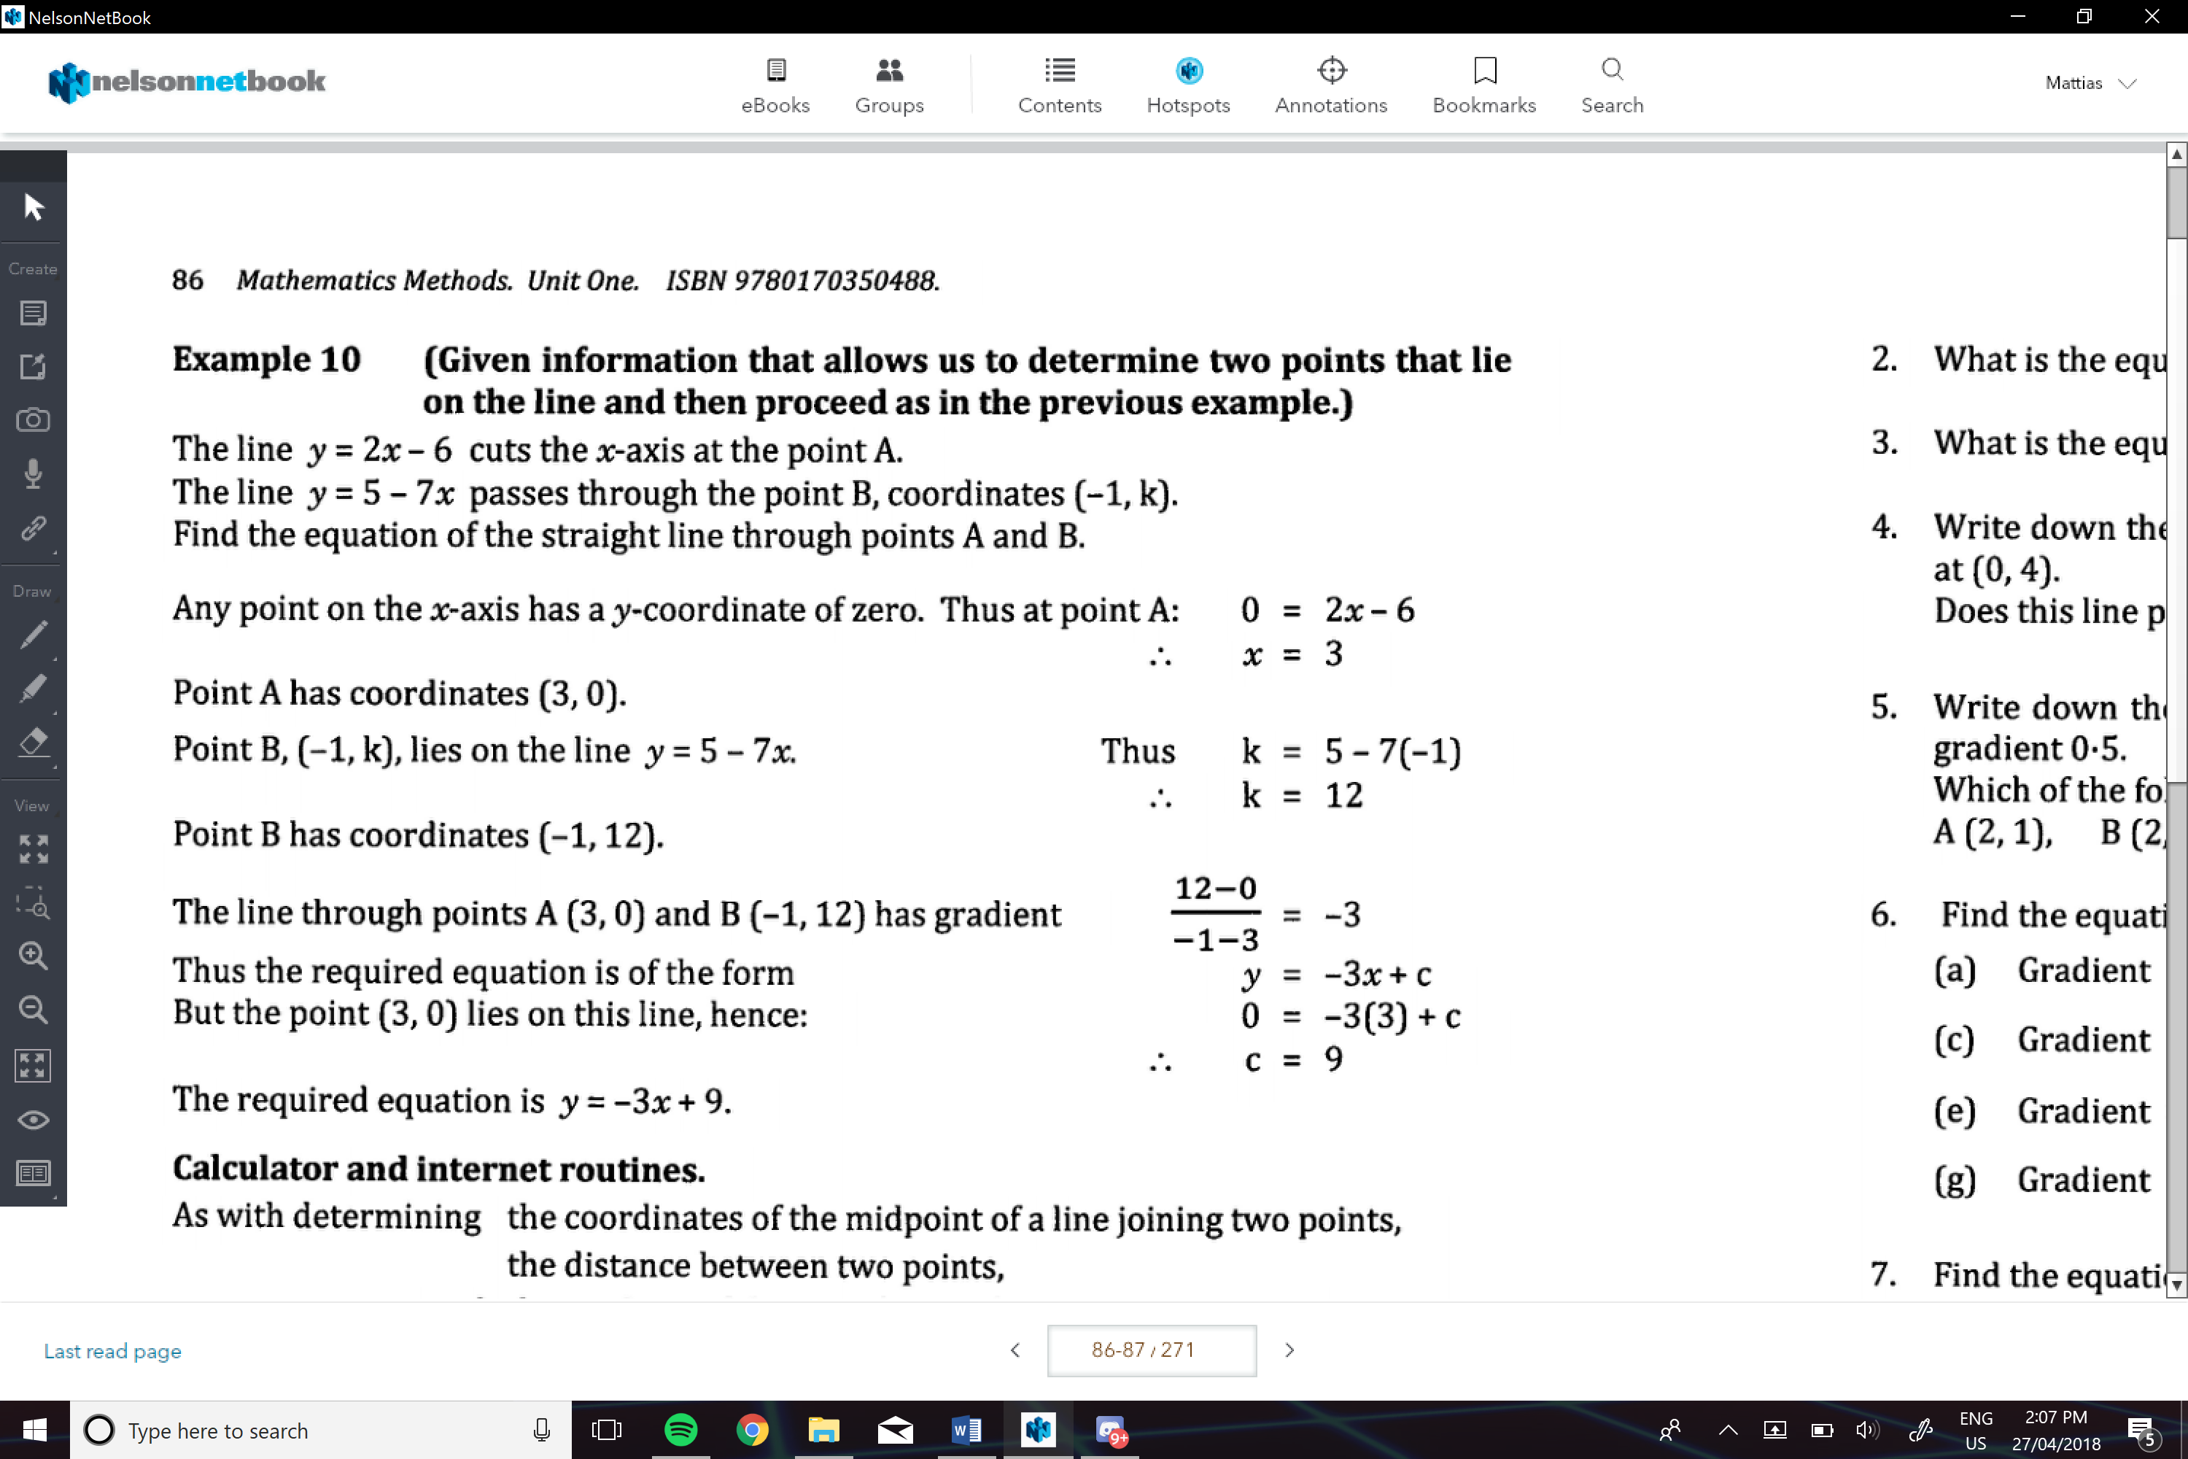

**Parrallel Lines:**

Are two lines that have the game gradient , and never touch

**Perpendicular Lines:**

Two lines that intersect each other at exactly 90o

* The gradients are the negative reciprocal of each other

-And the gradient should have a product of -1